WELCOME FOR PROJECT:
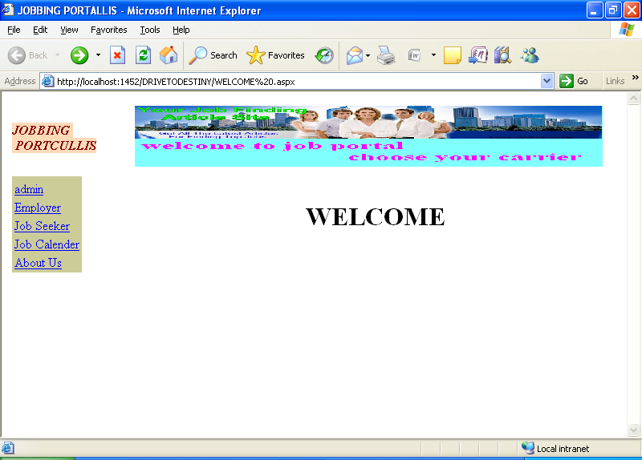
Pagename: homepage
Fields: child pages
Process: navigates to child pages
Table: no
Stored Procedure:no
Remarks: static page
Error: no

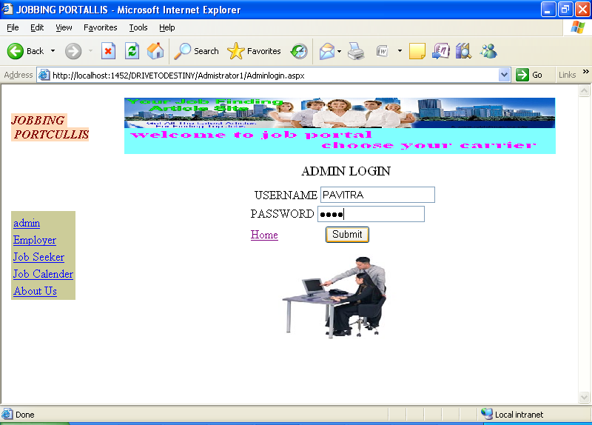
Pagename: Admin
Fields: username,password,submit
Process: navigates to admin page
Table: admin login
Stored Procedure: no
Remarks: enter into fields
Error: no

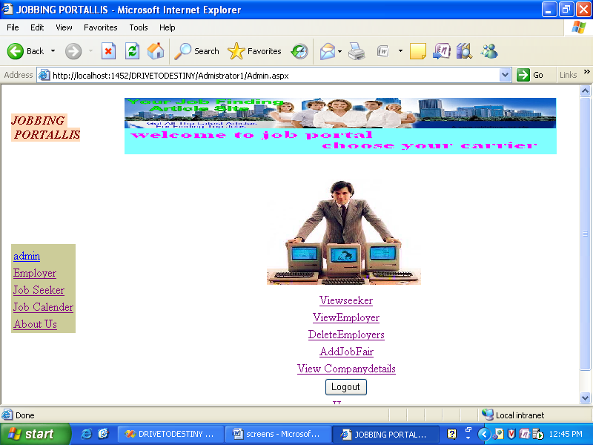
Pagename: Admin home page
Fields: admin child pages,logout
Process: navigates to admin childpages
Table: no

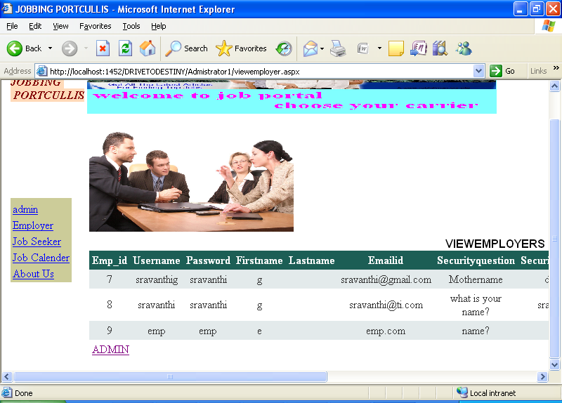
Pagename: VIEWING THE EMPLOYER DETAILS BY ADMIN
Fields: grid view
Process: admin can view emp details
Table: Emp_details
Stored Procedure: srp_Employer

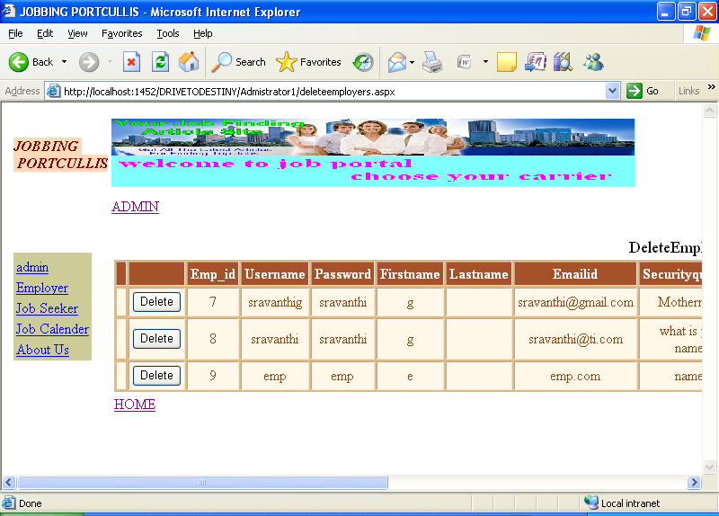
Pagename: DELETE THE EMPLOYER DETAILS BY ADMIN
Fields: grid view
Process: admin can delete emp
Table: Emp_details
Stored Procedure: srp_Employer

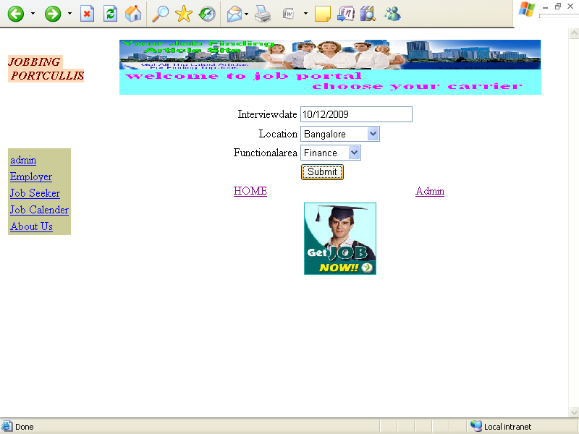
Pagename: SUBMIT THE JOBFAIRS BY ADMIN:
Fields: intervw date,location,submit
Process: admin can add job fair
Table: Job_fair
Error: no

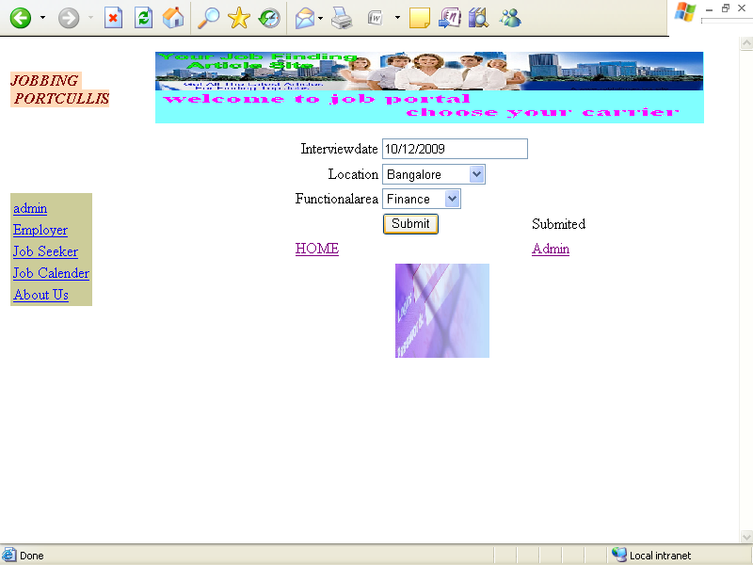
Pagename: ADDING JOBFAIRS BY ADMIN:
Fields: intervw date,location,submit
Process: admin can add job fair
Table: Job_fair
Error: no

VIEWING THE COMPANY DETAILS BY ADMIN:
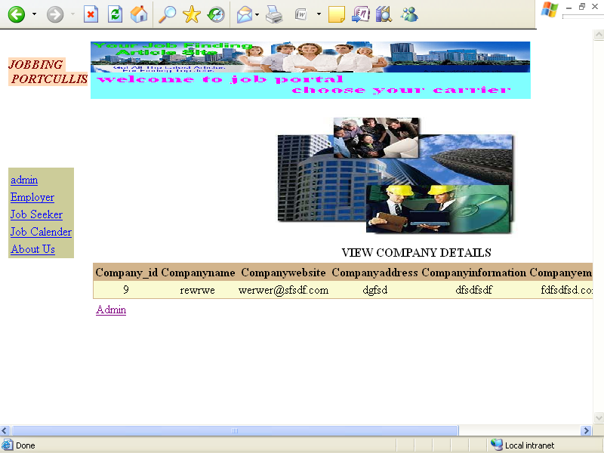
Pagename: VIEW THE JOBFAIRS BY ADMIN:
Fields: grid view
Process: admin can view job fair
Table: Job_fair
Error: no
EMPLOYER REGISTRATION FORM FOR NEW USER: 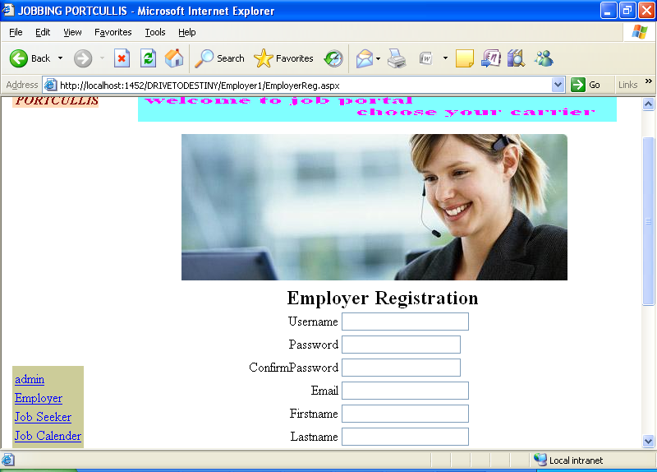
Pagename: employee registration
Fields: username,pwd,email,first name,last name,address
Process: takes user information
Table: emp_details
Stored Procedure:srp_employer
Remarks: enter into fields
Error: no

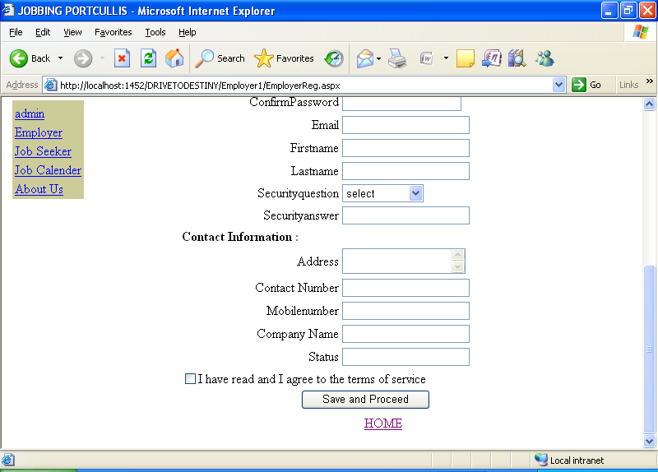
Pagename: employee registration
Fields: username,pwd,email,first name,last name,address
Process: takes user information
Table: emp_details
Stored Procedure:srp_employer
Remarks: enter into fields
Error: no

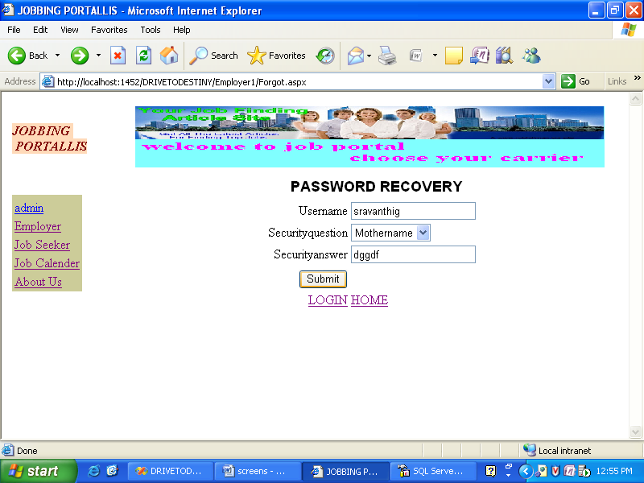
Pagename: PASSWORD RECOVERY FOR EMPLOYERS:
Fields: username,qus,ans
Process: emp can get pwd
Table: emp_details
Stored Procedure: srp_employer
Remarks: enter into fields
Error: no

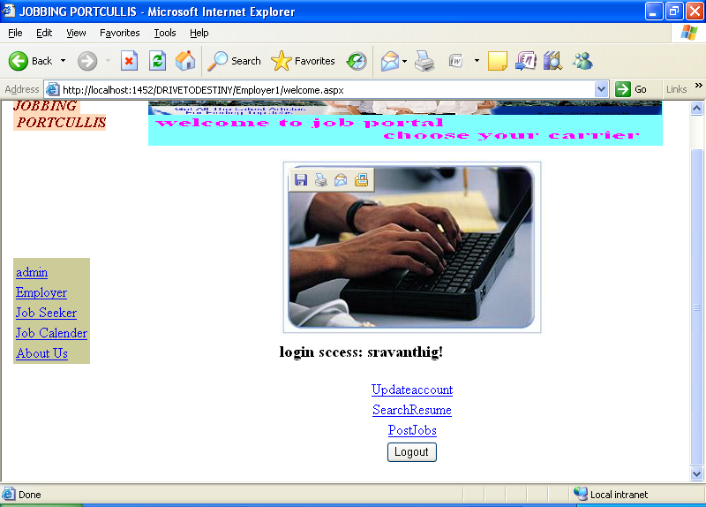
Pagename: FUNCTIONALITY OF EMPLOYER:emp home page
Fields: update account,search account,post jobs,logout
Process: navigates to above pages
Table: no

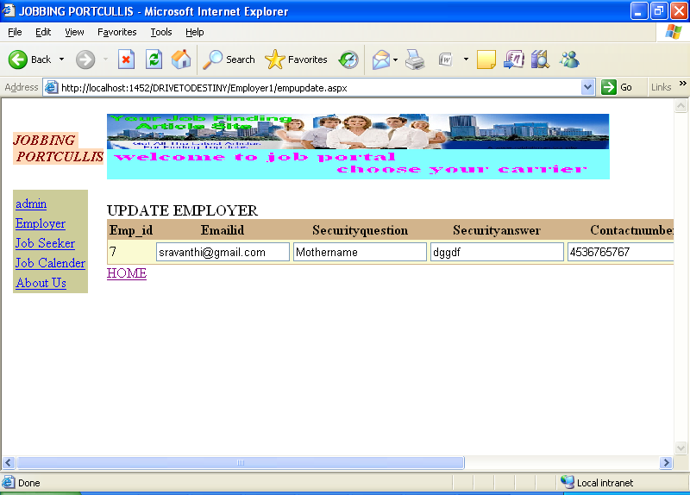
Pagename: UPDATING EMPLOYER DETAILS:
Fields: gridview
Process: can update details
Table: emp_details
Stored Procedure: srp_employer

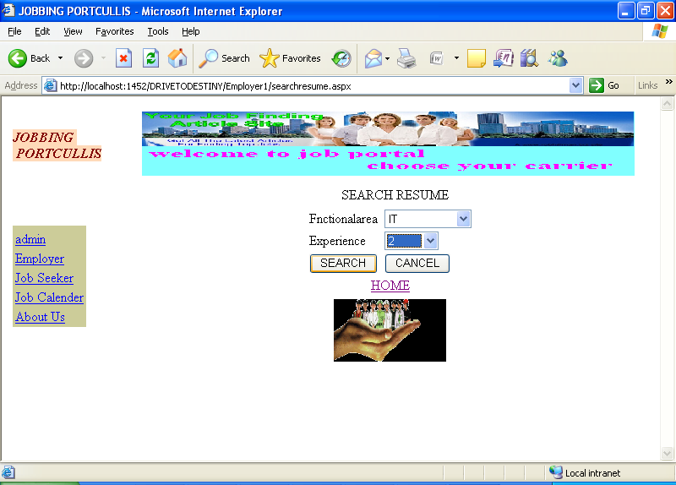
Pagename: SEARCHING THE RESUMES BY EMPLOYER:
Fields: area,exp,search
Process: can get details of resume
Table: Emp_resumedetails
Stored Procedure: sp_viewresume

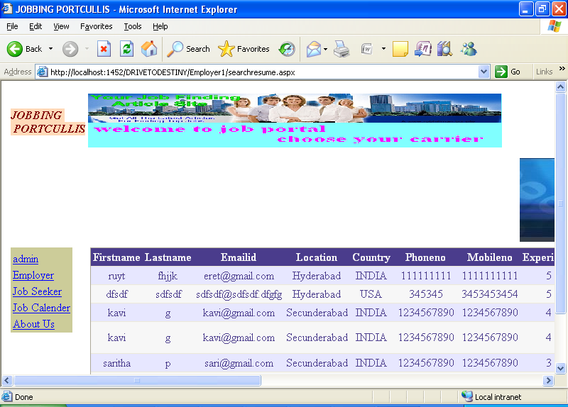
Pagename: DISPLAYING JOB SEEKERS DETAILS:
Fields: area,exp,search
Process: can get details of resume
Table: Emp_resumedetails
Stored Procedure: sp_viewresume

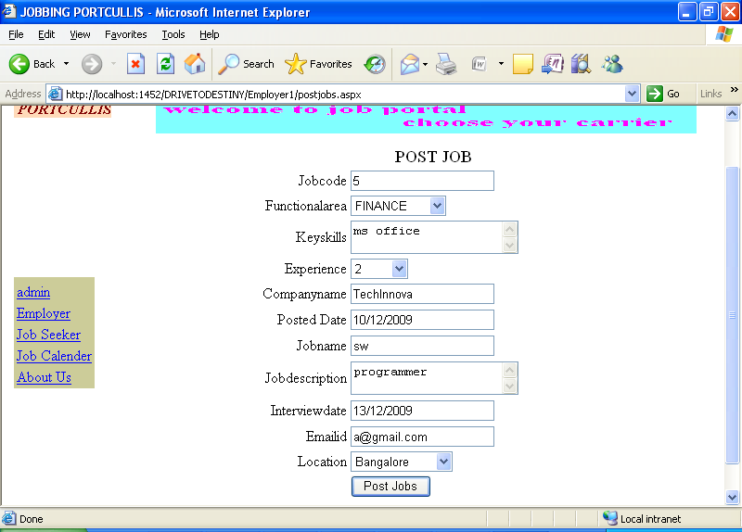
Pagename: JOB POSTING BY EMPLOYER:
Fields: jobcode,area,keyskills,exp,jobname,emailed,location
Process: emp can post for a job

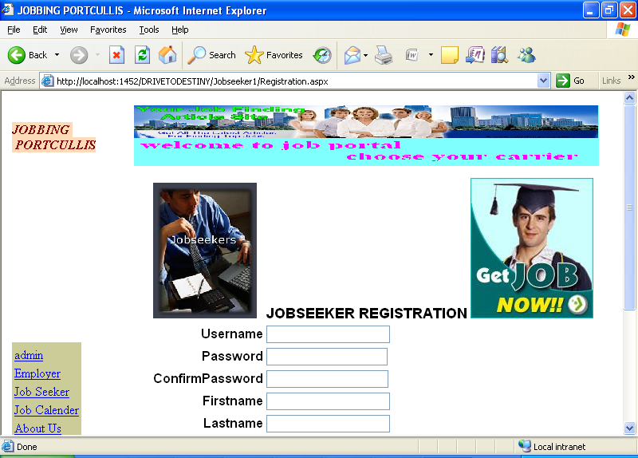
Pagename: JOB SEEKERS REGISTRATION FORM FOR NEW JOB SEEKERS:
Fields: username,pwd,confirm pwd,firstname,lastname
Process: job seeker have to register here
Table: Seeker_details
Stored Procedure: srp_Jobseeker
Remarks: enter into fields
Error: no

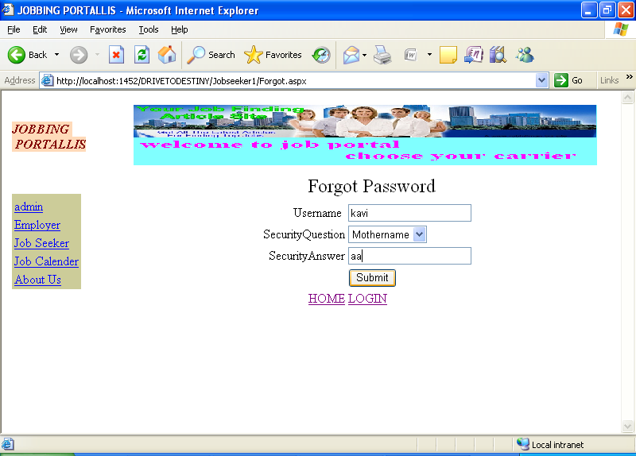
Pagename: FORGOT PASSWORD FORM FOR JOB SEEKERS:
Fields: username,qus,ans,submit
Process: jobseeker can get his password
Table: Seeker_details
Stored Procedure: srp_Jobseeker
Remarks: eneter into fields
Error: no

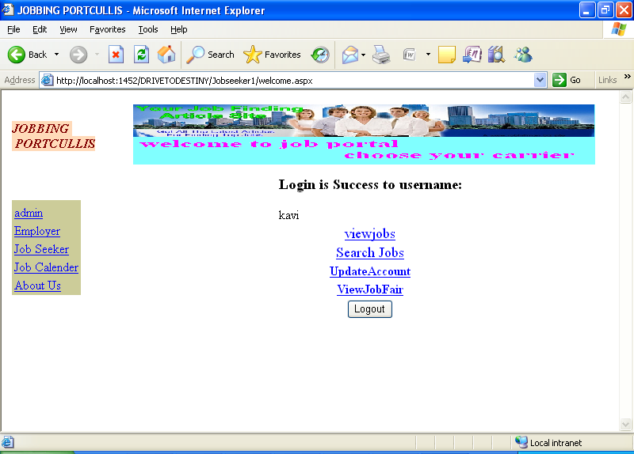
Pagename: FUNCTIONALITY FORM FOR JOB DEEKERS:
Fields: viewjobs,search,update,view jobfair
Process: navigates to above pages

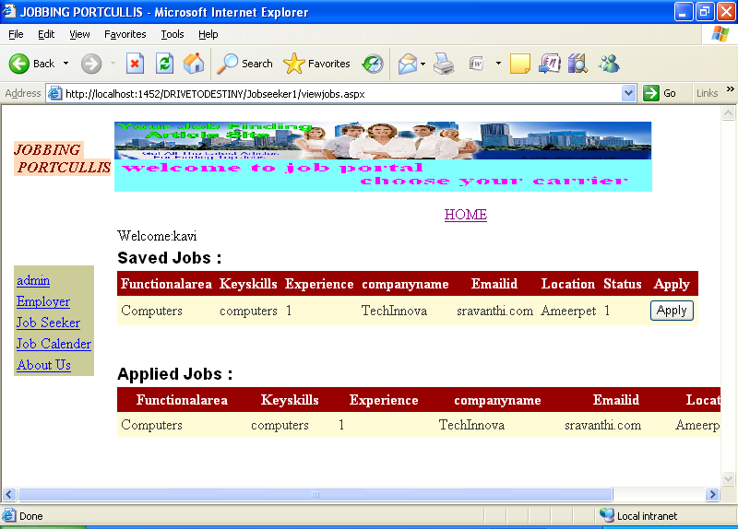
Pagename: VIEWING THE JOBS BY JOB SEEKERS:
Fields: grid view
Process: job seeker can view the jobs
Table: no
Stored Procedure: sp_getseekerjobs

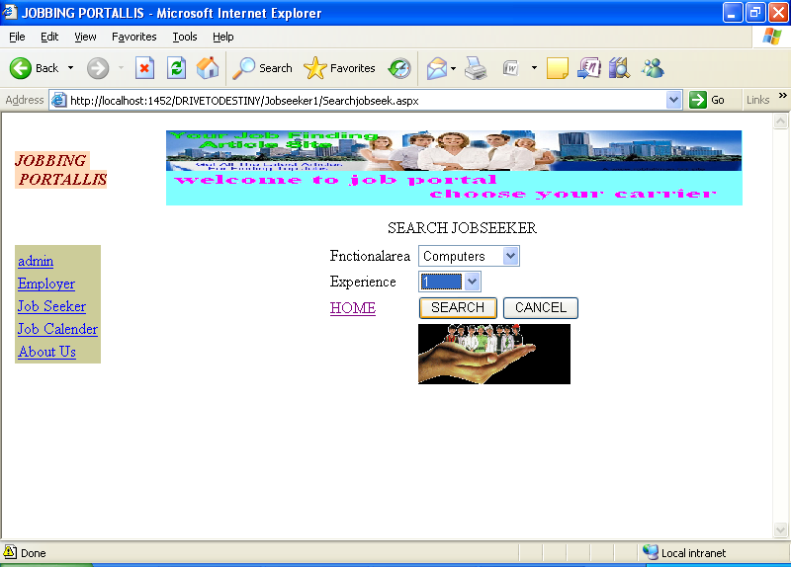
Pagename: SEARCHING JOBS BY JOB DEEKERS:
Fields: area,exp,search
Process: job seeker can search jobs
Table: Seeker_jobdetails
Stored Procedure: sp_getseekerjobs
Remarks: enter intofields
Error: no

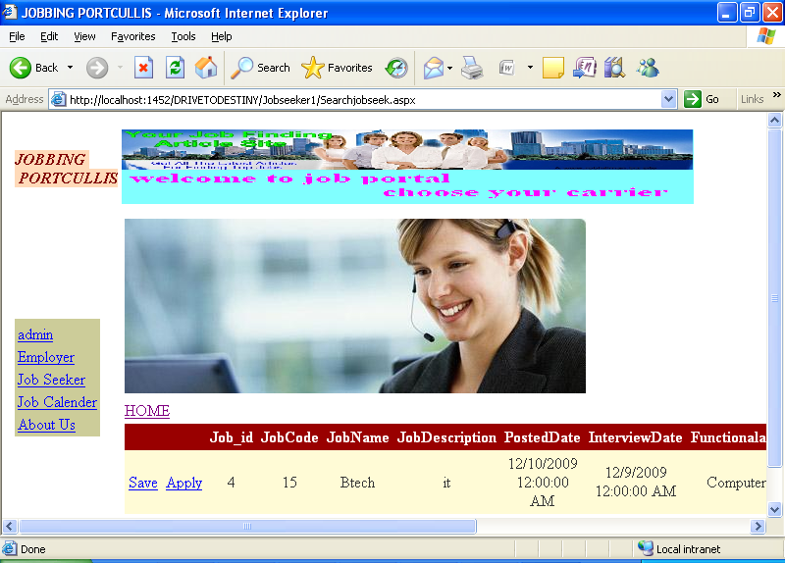
Pagename: DISPLAYS JOB DETAILS:
Fields: grid view

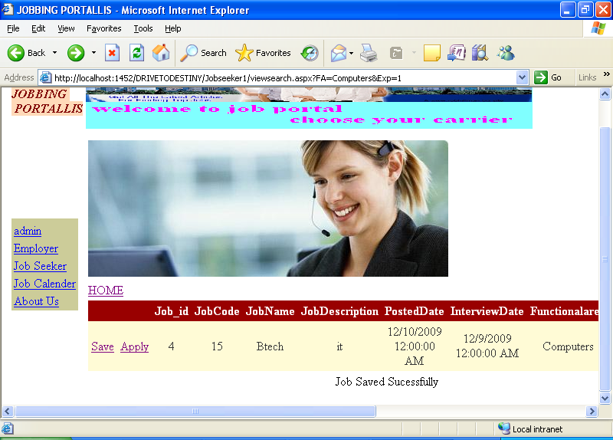
Pagename: SAVING THE JOBS BY JOB SEEKERS:
Fields: grid view
Table: no
Stored Procedure: sp_getseekerjobs_saved
Error:no

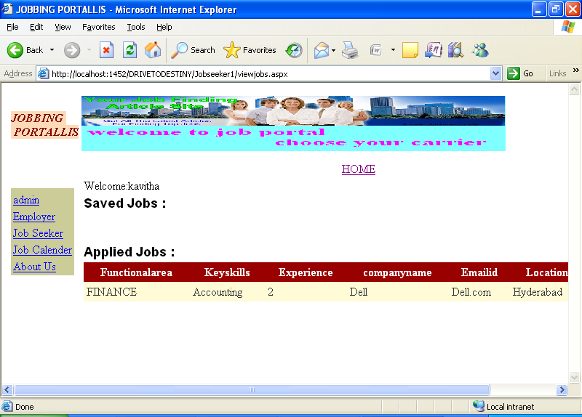
Pagename: DISPLAYING APPLIED JOB DETAILS:
Fields: grid view
Process: displays applied jobs
Stored Procedure: sp_getseekerjobs_applied

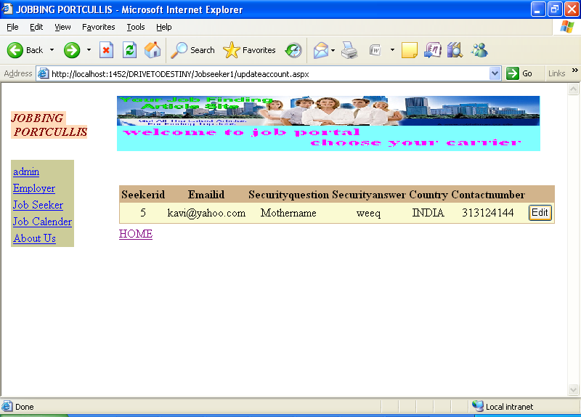
Pagename: UPDATE SEEKER ACCOUNT:
Fields: grid view
Process: can update
Table: no
Stored Procedure: usp_seekupdate

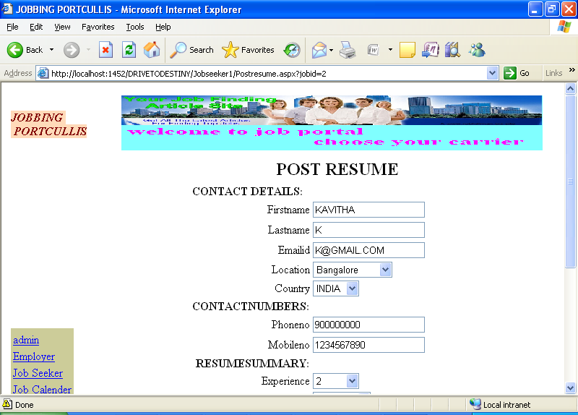
Pagename: POSTING RESUME FOR APPLIED JOBS:
Fields: conact details,numbers,resume summary
Process: can post resume
Table: POSTING RESUME FOR APPLIED JOBS:
Stored Procedure: srp_PostResume
Remarks: enter into fields
Error: no

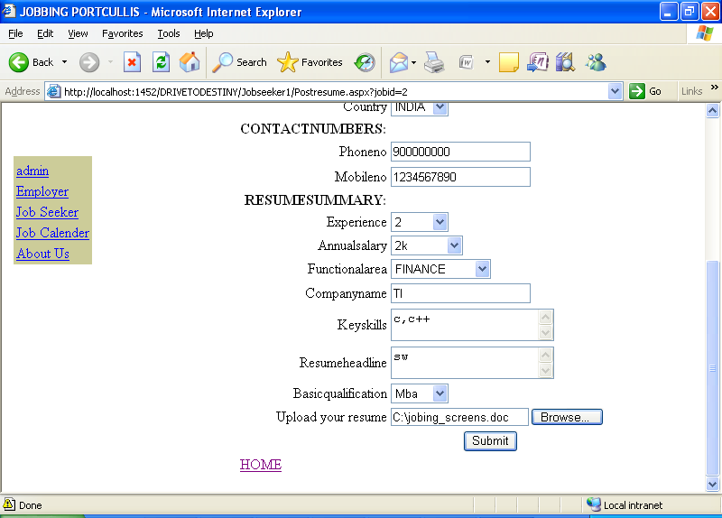
Pagename: POSTING RESUME FOR APPLIED JOBS:
Fields: conact details,numbers,resume summary
Process: can post resume
Table: POSTING RESUME FOR APPLIED JOBS:
Stored Procedure: srp_PostResume
Remarks: enter into fields
Error: no

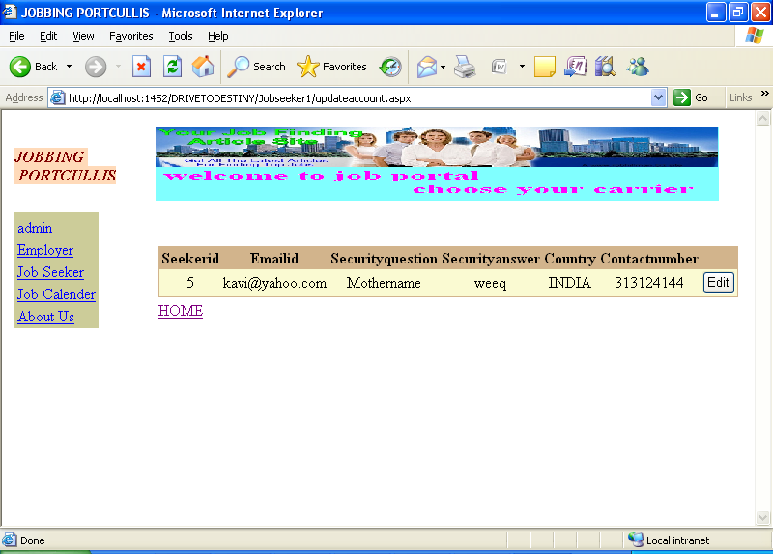
Pagename: UPDATING JOB SEEKER DETAILS:
Fields: grid view
Process: can update
Table: no
Stored Procedure: usp_seekupdate

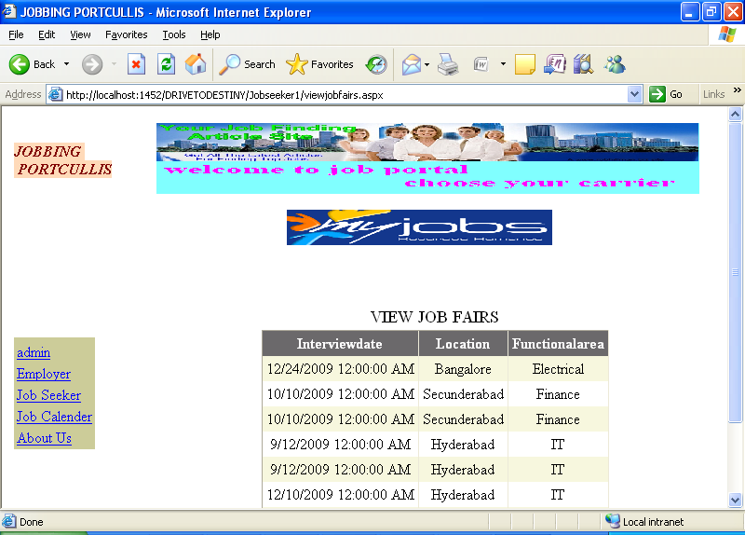
Pagename: VIEWING JOB FAIR DETAILS BY JOB SEEKERS:
Fields: grid view
Process: can view job fairs
Table: Job_fair

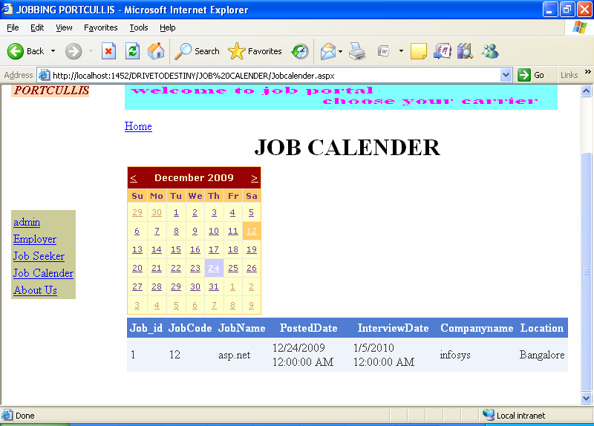
Pagename: DISPLAYING JOB DETAILS ON PARTICULAR DATE:
Fields: calendar,grid view
Process: jobc by date

